**Testcase I – When loan is ineligible due to one of the conditions**

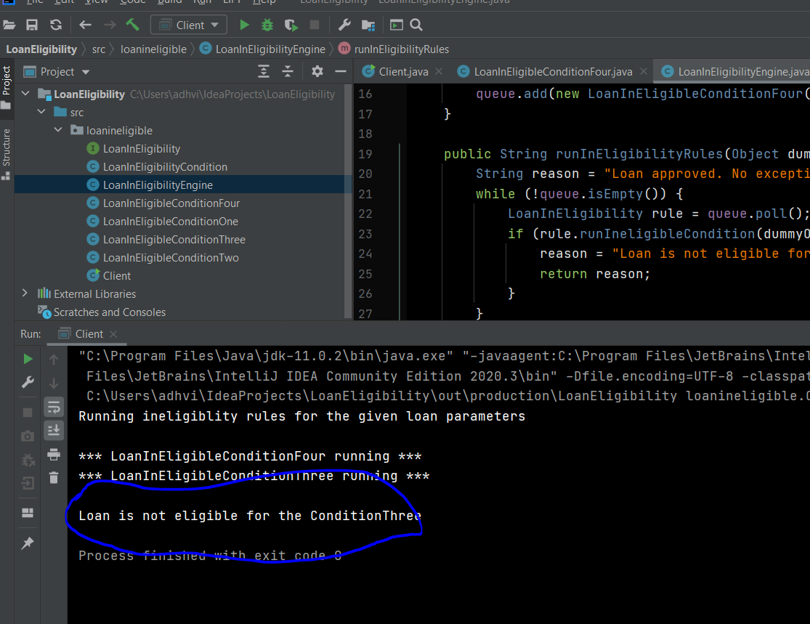

**Testcase II – When the loan is exempted from all ineligible conditions.**

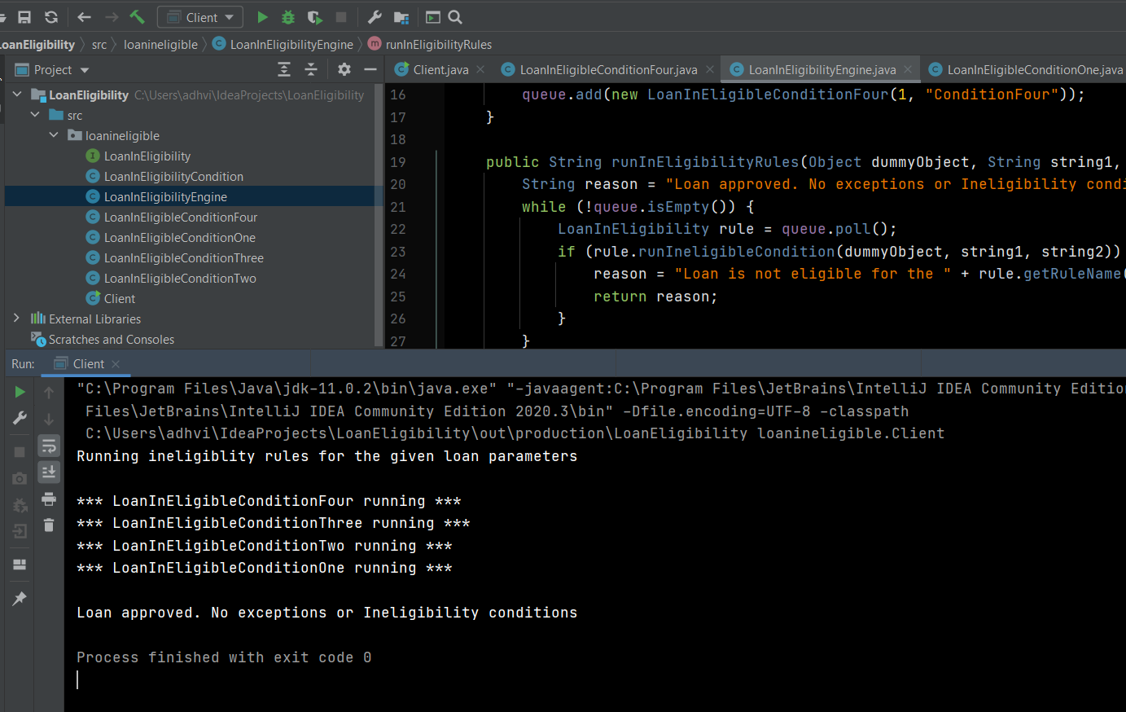

**Testcase III – Change the condition order and run.**

Current rule order

|  |  |
| --- | --- |
| Order | Rule |
| 1 | ConditionFour |
| 2 | ConditionThree |
| 3 | ConditionTwo |
| 4 | ConditionOne |

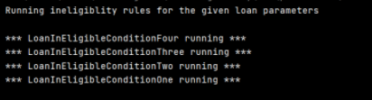

New rule order

|  |  |
| --- | --- |
| Order | Rule |
| 2 | ConditionFour |
| 3 | ConditionThree |
| 1 | ConditionTwo |
| 4 | ConditionOne |

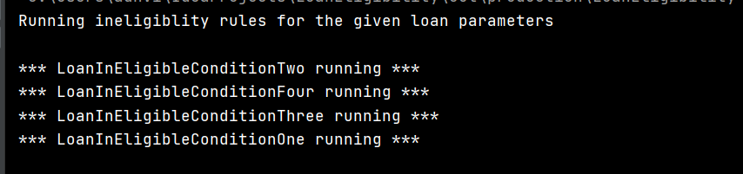

**Testcase IV – Add a new rule(conditionFive) with priority 1 without modifying the existing rules and run**

|  |  |
| --- | --- |
| Order | Rule |
| 2 | ConditionFour |
| 3 | ConditionThree |
| 1 | ConditionTwo |
| 4 | ConditionOne |
| 1 | ConditionFive |

